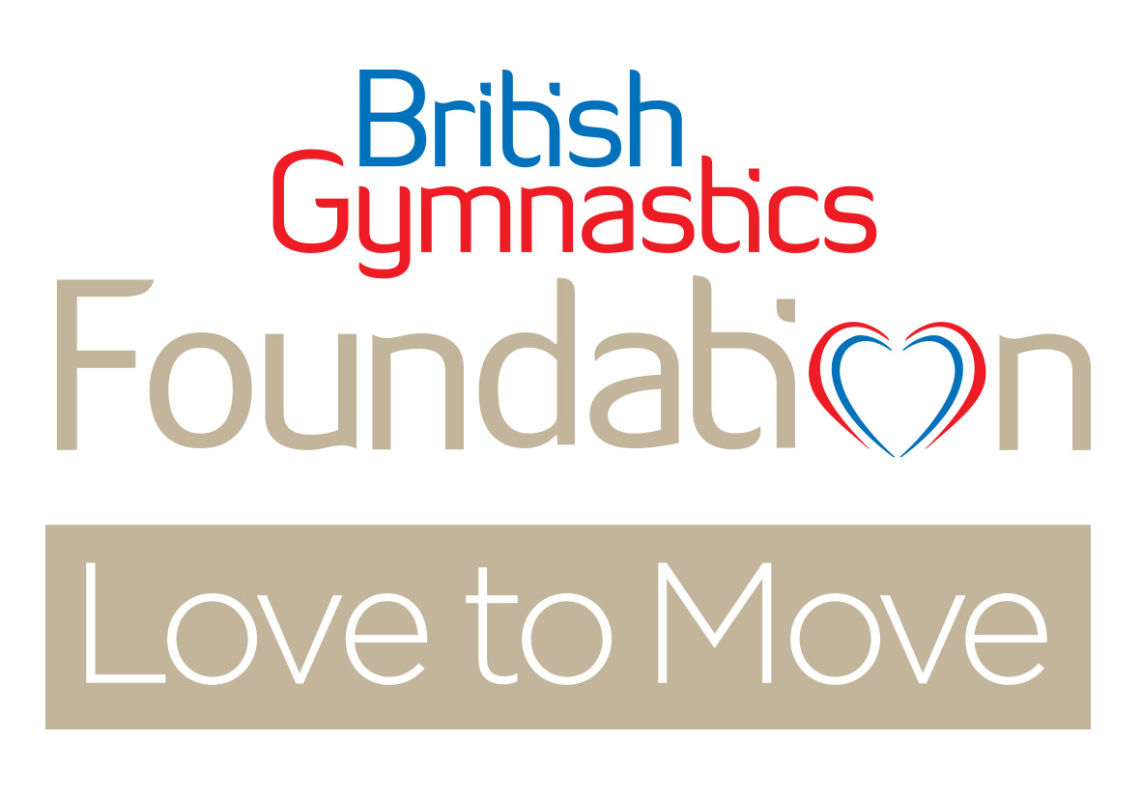
Love to Move Deliverers Course
Remote learning – Online course #57
Date: 31st January 1st, 8th & 9th February 2023
9.00am – 12.30pm each day
ENROLMENT FORM

Love to Move is an age and dementia friendly seated movement programme unlike any other. The programme has its roots taken from gymnastics and uses specially designed coordination and bilaterally asymmetrical movement patterns, which are thought to have the effect of increasing a person’s cognitive reserve.

Research on the programme to date has identified that Love to Move can make a significant impact on the quality of life for older people and in particular, those living with dementia appear to benefit the most.

In order to best support your needs pre and post course as well as on the course itself, we have a few questions to ask you as part of our enrolment process. It is important to us that learners have enough experience, either working with older people, people who are living with dementia, or general activity delivery experience, before embarking on delivering Love to Move independently. The course in itself may not be enough to build your confidence to deliver depending on your previous experience, knowledge and skills. We want you to become a great Love to Move deliverer and to support you as much as we can. This could take the form of mentoring post-course, or co-delivery.

Please fill out all details on this form and return to theteam@britishgymnasticsfoundation.org

By Monday 23rd January 2023.

- Full Name

- Address
(We need this to post resources to)

- Email address & mobile phone number
(NB: for course enrolment purposes we require your email address. In preparation for some of the course activities, learners need to access audio files which is most easily done via a smart phone.)
Email:

Mobile Phone Number:
Is your mobile phone a smart phone? Yes ☐ No ☐
(iPhone or Android)

- Year of Birth (you must be over 18 yrs. to attend the course)

- Do you have any impairments which may mean you need additional support on the course? | Yes ☐ No ☐
If yes, please outline below:

- Please tell us why you wish to do this course and about any relevant personal or work experience and/or qualifications which would support your effectiveness to deliver a programme such as Love to Move, for older people:

- Do you have any experience of working with people who are living with dementia or other forms of cognitive decline, brain disease or brain injury?
Yes ☐ No ☐
If yes, please outline what experience you have had:

- On average, how many people over the age of 55 are you currently delivering physical activity programmes to weekly?

- Do you have a specific class/ Care Home or Community Centre where you are going to deliver Love to Move?
Yes ☐ No ☐
If yes, please state where this is; and any volunteer/ staff support you expect to have working with you to assist the class.

- Do you currently link with or work in partnership with any organisations that support or provide services for older people?
Yes ☐ No ☐
If yes, please state which organisations you work with and what your relationship is with them:

Course Cost:
The course cost is £350 per person which includes your post-course assessment. Please indicate which method of payment you are using below:

Methods of payment: | Tick
BACS – Please email your form back and check this box to indicate you will be paying by BACS. We will provide BACS details to you once we confirm your place on the course. Please provide payment within 7 days of receiving your confirmation email.
Invoice – to company. Please state which company will be paying for your place and give a named contact, address & email address for the invoice.
………………………………..……………………………………………………………
NB: Please ensure payment is made on receipt of the invoice, in order for your resources to be posted to you before the course starts.

Thank-You for taking the time to complete this form.
Please return to: theteam@britishgymnasticsfoundation.org

