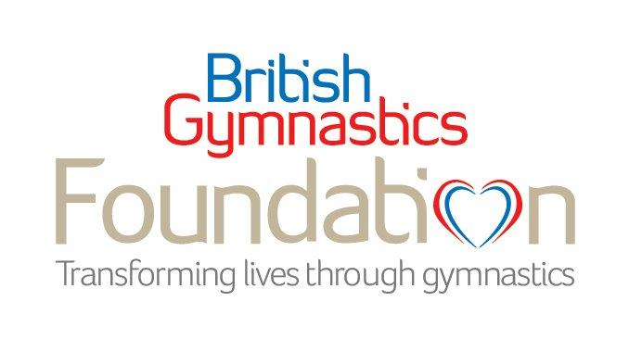

TCS London Marathon 2022 charity place application form: Sunday 2nd October

We’d love to invite you to apply for the British Gymnastics Foundation 2022 TCS London Marathon charity place. Please complete this form to be considered. Should you be successful, we will support you all the way with fundraising and training support. There is a registration fee of £50 and a minimum sponsorship of £2000.

Title: | First name: | Surname:
Address:
 |  | Postcode:
Email:
Telephone: |  | Date of birth:
1. How did you hear about the British Gymnastics Foundation Marathon place?
2. What/who has inspired you to take on a marathon?

3. Do you have a connection to the British Gymnastics Foundation’s work? (i.e. a connection to gymnastics or dementia)

4. Have you run a marathon before? |  |  |  |  |  | Yes | No
5. What is your predicted finish time?
6. Your job title: |  | 6.a. Organisation name:
6.b. Does your company offer matched funding? |  |  | Yes | No | Don’t know
6.c. If you answered yes, how much will your company match? |  |  | £
7. How much do you hope to fundraise for the Foundation should your application be successful? (minimum target £2000) |  |  |  |  |  | £
7.a. How would you plan to raise this money? Please be as detailed as possible.

I am happy to receive phone calls related to my London Marathon place | Yes | No
I am happy to receive emails to update me about the London Marathon, training and fundraising tips | Yes | No

Thank you so much for your time and interest

Please return this form to theteam@britishgymnasticsfoundation.org by Monday 27th June and we will get back to you as soon as we can.

Your privacy
Thank you for supplying this information. This information will be held during the selection process for our Charity place for the London Marathon 2022. You can withdraw your consent for us to keep this information by emailing theteam@britishgymnasticsfoundation.org at any time. Please find our full Privacy Statement here: https://britishgymnasticsfoundation.org/privacy-statement/

Terms and conditions of entry

1. If successful, you will be required to pay a non-refundable registration fee of £50 within 15 working days of receiving your confirmation email. If you have not paid by this deadline, we will assume you no longer want our 2022 TCS London Marathon place and give your place to another runner.
2. By registering for a Charity Place in the 2022 TCS London Marathon you are committing to a minimum fundraising amount of £2000. The total sum should be sent to the British Gymnastics Foundation no later than eight weeks after the event and understand that it is the endeavour of this challenge to raise as much above this as possible in aid of the British Gymnastics Foundation.
3. You agree to represent and raise money exclusively for the British Gymnastics Foundation in this event.
4. Of sponsorship raised, approx. £330 will be used to cover the cost of your place in the marathon. The remainder of the funds raised will go directly towards the work of the British Gymnastics Foundation.
5. No refund will be made in event of cancellation by you, the event organiser or the British Gymnastics Foundation (except as described in point 6 below) as sponsorship raised is for charitable purposes.
6. Should you have to withdraw for any reason, you should inform the British Gymnastics Foundation in writing, send all sponsorship forms and money collected directly to the charity, and notify your sponsors that you are no longer taking part. All sponsorship monies will be retained by the British Gymnastics Foundation unless your sponsors request in writing that the charity return it to them within one month of your cancellation (not applicable for online donations).
7. It is strongly advised that you train for the London Marathon. If you have not exercised for some time or if you are in any doubt as to your physical ability to take part in this event, you must seek medical advice from your general practitioner.
8. You are entering this event entirely at your own risk and the British Gymnastics Foundation shall not be liable for any injury or loss that might occur as a result of your participation.
9. The swapping or sale of race numbers is strictly prohibited for reasons of safety and primarily for identification by medical staff.
10. You must be at least 18 years old by race day (estimated to be Sunday 2rd October).
11. You will receive an email from the London Marathon organisers and need to complete the official online console within 2 days of receiving the email. If the console is not complete within the allotted time set by London Marathon Events Ltd you will not be able to run, there will be no exceptions.
12. British Gymnastics Foundation has the right to remove any runner from the team if it is known that the minimum fundraising amount will not be met or an effort to reach the required amount is not committal.

theteam@britishgymnasticsfoundation.org
britishgymnasticsfoundation.org

Registered Charity No. 1157747

